### GRASS VALLEY FRIENDS MEETING

Of the Religious Society of Friends of the Truth

College Park Quarterly Meeting, Pacific Yearly Meeting

### MINUTES & RECORD

Meeting for Worship on the Occasion of Business

August 10, 2025

We met in a hybrid meeting in person at the meetinghouse and on Zoom.

**Present:**  Dorothy Henderson, clerk; Jennifer Smith, recording clerk; Gordon Starr (elder to the clerk), Stuart Smith, Amy Cooke, Chamba Cooke, Peter O’Rourke, Dianne Marshall, Judy Hamilton, Reed Hamilton, Doug Hamm, Mary Starr, Dean Olson,

The Meeting opened with silent worship.

##### **Clerks’ Remarks and Query**

* Is Meeting for Worship for Business useful for building “Beloved Community,” not just for business? Can we move our business into committees so that we can focus more on spending our time on building our relationships in our Beloved Community.
* Query: Is monthly Meeting for Worship for Business the best use of our time for building beloved community?
* Do we need to meet every month, or would every other month for Meeting for Worship for Business suffice? Should we do something else during the other months to help build community?
* Friends spoke out of the silence:
  + If our meeting is taking on a challenging issue, it might be necessary to meet every month. If not, every other month might be sufficient.
  + Business Meeting can be a struggle to sit through, even though it is valuable to work through our business together. This friend would welcome building community in a different way.
  + Beloved Community can extend out into the wider world. Bringing our Quaker Process out into the world is valuable.
  + Meeting for Worship for Business can be more compact when the committees do their work. We might not need to do this every month. However, there will be times when it is needed, and other times when it is not.
  + The metaphor of weaving a basket comes to me. Whether we are sitting in Meeting for Business and discerning on an issue, or participating in a work day, or a potluck, there are different strands coming together to weave a strong beautiful basket of Beloved Community. What would it be like if we were gathering because the work is imperative, needed, and urgent?
  + France Yearly Meeting makes all decisions in a representative committee in order to do relationship and spiritual deepening during the annual session. This is offered as comparison with other meetings grappling with this issue.
  + There is something to be said for business being held in worship. The question is between “worship” and “social?”
  + Sometimes there are pragmatics that keep an organization whole and running that need active participation. Meeting for Worship for Business keeps me engaged.
  + Sometimes it is difficult to come monthly with new ideas that are valuable for Meeting for Worship for Business, especially as a Clerk of the Welcome Committee. There might be better uses of time for every other month.
  + Having Meeting for Worship for Business being more compact makes it easier to participate in. Committees have made that possible.

##### 

##### COMMITTEE REPORTS

(see reports appended, committee clerk is noted in bold)

**Spirit and Witness: Amy Cooke,** 2024-2027,Stuart Smith, 2025-2026, Reed Hamilton, 2025-2028, Dean Olson, 2024-2027, Doug Hamm, 2025-2026, Dorothy Henderson, 2026 (ex-officio, GVFM Clerk), Gordon Starr (ex-officio, elder to the clerk).

Amy Cooke gave the report, appended.

**MINUTE 2025.08.01: Grass Valley Friends Meeting releases Charity Bryson from membership in Grass Valley Friends Meeting. A certified letter notifying her of this release of membership was returned unopened.**

**MINUTE (seasoning until 9th month): Grass Valley Friends Meeting approves the Minute of Service letter for Stuart Smith.**

* The Minute of Service letter was read for Stuart Smith. There was a question about what this Minute of Service is addressing. Some clarification was needed.
  + Stuart plans to travel to other meetings to express his concern on peace education especially for high school youth, and to have an introductory letter to other meetings. It serves as an introduction and to show that the visit is supported by the Grass Valley Friends Meeting.
* There was another question about the locations for the Season of Nonviolence programs. Interfaith Nevada County would like to participate. Attendance would be higher if these programs were held at a different location.
  + Having a location in town is an issue that Meeting needs to look into and has come up multiple times among members and in Spirit and Witness.
  + There is a concern about how the Nisenan and CHIRP will feel about having the public come onto the land here for programs.
  + We may need to discern about having someone work on finding locations in town. There is a time element with the flier going out, and listing locations.
  + Interfaith Nevada County is a good resource for us to reach out to for facilities. There is receptiveness and cooperation there.

**Stewardship: Mary Starr (Treasurer),** Gordon Starr, Pat Phillips, Reed Hamilton, David Bowman. Dianne Marshall (ex-officio, Newsletter editor), Don McCormick (ex-officio, Librarian), Hailey Wilson (ex-officio Tech Support).

Mary Starr gave the report, appended.

* Was CHIRP contacted about the rodent issue, specifically, was Saxon notified?
  + Yes, though things are still in flux. Traps were set and a rodent was caught.

**Welcome: Peter O’Rourke** (ex-officio, Website and Facebook coordinator), Kathy McCreery, Don McCormick, Pat Phillips, Cindy Bliss, Lo Hamm, Judy Hamilton (ex-officio email coordinator), Nancy Anderson (ex-officio directory clerk).

Peter O’Rourke gave the report, appended.

* How does the guestbook entry work with the postcard and/or welcome bags?
  + The welcome bags need to be looked at by the Welcome Committee in their next meeting to address this.
  + The guestbook entry will get added to the email list and the newsletter list.
* There were questions about what YubaNet does. It lists events in the community and can be used to list our worship events.

**Nominating Committee: *(terms as noted)***, Chamba Cooke: 2025-2026, Dean Olson 2025-2027, Mary Starr 2025-2027, fosten wilson 2024-2026,

No report was given.

**Religious Education: Judy Hamilton**, Doug Hamm, Dean Olson, Reed Hamilton, Don McCormick,Keely McDonald, Lo Hamm. Substitutes: Gordon Bishop, Gordon Starr, Alan Stahler. Fifth Sunday reader: Anita McCormick

Judy Hamilton gave the report, appended.

##### OFFICER REPORTS and REPRESENTATIVE REPORTS

**Treasurer:** Mary Starr gave the report, appended.

**Pacific Yearly Meeting**: Doug Hamm gave the report, appended.

**College Park Quarterly Meeting:** No report given.

**Interfaith Nevada County**: Dianne Marshall gave the report, appended.

**Sharings from the wider Quaker world**:

* QUAKER CALL TO ACTION:
  + 8-3-25 Eileen Flanagan "RESISTING THE DIVIDE AND CONQUER GAME." Presentation by Eileen Flanagan extracted from 8-3-25 National Zoom Call "Resisting The Divide and Conquer Game: How Quakers Can Help the Broader Pro-Democracy Movement."
  + 6-1-25 Daniel Hunter "DEFENDING OUR DEMOCRACY: WHERE ARE WE AND WHAT'S NEXT?” <https://choosedemocracy.us/>
* Yesterday was the world premiere of *Living Ubuntu*, created by Friends in the wider world. We should look at viewing this in our meeting.
* US Quakers in Europe are group sharing ways to maintain nonviolence and solidarity with American struggles.

##### CLERK’S REMARKS:

* This meeting and its members have a rich history. We care deeply about issues and hold each other, and our meeting, tenderly.
* When we come together, we create something greater than just ourselves.

##### ITEMS SEASONING or CARRIED OVER

**MINUTE (seasoning until 9th month): Grass Valley Friends Meeting approves the Minute of Service letter for Stuart Smith.**

##### ANNOUNCEMENTS

* **College Park Quarterly Meeting:** Fall Meeting is scheduled for the weekend of October 17-19, 2025, at Ben Lomond Quaker Center.
* **Facebook:** please follow the Grass Valley Friends Meeting page, or join the Facebook Grass Valley Friends Meeting group. If you share a post from the page, your friends will see it, and it helps our visibility. Follow this [link.](https://www.facebook.com/GrassValleyFriendsMeeting/?view_public_for=108833097152257)
* The **2023-2024 PacYM General Directory.** The directory is now available. The Directory is for use by members and attenders of monthly meetings and worship groups within Pacific Yearly Meeting and by Friends serving on Pacific Yearly Meeting committees. It is not to be shared beyond this community. Dorothy and Don have the new password for the PacYM Directory.
* **Carl Magruder:** You can follow Carl’s healing journey on the CaringBridge.org website [HERE](https://www.caringbridge.org/visit/carlmagruder). Friends have also set up a daily Meeting for Healing from 7:30 to 8 am (Pacific) on Zoom [here](https://us02web.zoom.us/j/85108606375?pwd=MmdDczRVd3MxQUxtLzBEUExxMDU0QT09) or contact Amy Cooke at amylisette@gmail.com for the link.
* **Contributions to Grass Valley Friends Meeting** are gratefully accepted. You can give by mailing a check to Mary Starr or through Tithely on the website or our newsletter.

##### 

##### READING OF THE RECORD AND MINUTES

The record and the minutes were read, corrected, and approved.

If you are giving a report to GVFM, please send the actual report to the recording clerk at **jenniferjksmith@gmail.com** THE WEDNESDAY BEFORE MEETING FOR BUSINESS and share with both Dorothy and Jennifer.

GVFM Newsletter Reminder: Please have items into Dianne Marshall by Tuesday at 10 am.

The Meeting closed with silent worship.

Respectfully recorded by Jennifer Smith, recording clerk.

## 

## APPENDICES:

1. Spirit and Witness Committee report
   1. Minute of Service letter for Stuart Smith
   2. A Season for Nonviolence Poster - Fall 2025
2. Stewardship Committee report
3. Welcome Committee report
4. Nominating Committee report
5. Children’s Committee report
6. Treasurer’s Report
7. Pacific Yearly Meeting report
8. Interfaith Nevada County report

-------------------------------------------------------------------------

**Spirit & Witness Report**

**08.2025 Spirit and Witness Report**

Our committee has been in ongoing discernment about how we integrate our spiritual lives with our outward witness in the world. How do we act from spiritual grounding as we engage with the concerns and needs around us?

The *Toward Right Relations Witness Committee*, which meets under our care, is planning to share a Friends Peace Teams film with the Meeting in October. In support of our collective awareness and engagement, we have also decided to begin sharing the CHIRP (California Heritage: Indigenous Research Project) newsletter through the Meeting’s email tree. This will help ensure that Friends can stay up to date with the CHIRP’s activities.

Additionally, we are recommending that the Nominating Committee consider appointing Dean Olson to the California Heritage: Indigenous Research Project and Nisenan liaison role, to serve alongside Dorothy as co-liaison.

A significant portion of our recent meeting was devoted to further discernment about our Meeting’s involvement with local immigration issues. Some members of our Meeting have been attending gatherings of the Nevada County Immigrant Rights Network, and we encourage all Friends to participate as they feel led. We also discussed the potential creation of a new Witness Committee focused on immigration issues. If you are interested in being part of this effort, please contact Amy Cooke.

The *Programs Committee,* which also meets under our care, has been developing after-Meeting programs for the Fall. We are naming this season the GVFM Season for Nonviolence, with all programs reflecting and supporting this central theme. Below is our current lineup (titles and descriptions may be revised as needed):

* **August 24** – *Don McCormick*: Worship Sharing on Nonviolence
* **September 28** – *Dorothy Henderson and Gordon Starr*: Nonviolence as a way of life
* **October 5** – *Dianne Marshall*: Daniel Hunter: A Quaker Call to Action (recording and discussion)
* **October 26** – *Reed Hamilton*: *Toward Right Relations* Quaker Peace Teams (film and discussion)
* **November 23** – *Doug Hamm*: A Force More Powerful (film and discussion)
* **December 20** – *Amy Cooke*: Stop, Drop, and Roll: A Practice for Living Nonviolently

We hope these offerings will nourish our spiritual grounding and strengthen our collective witness in the world.

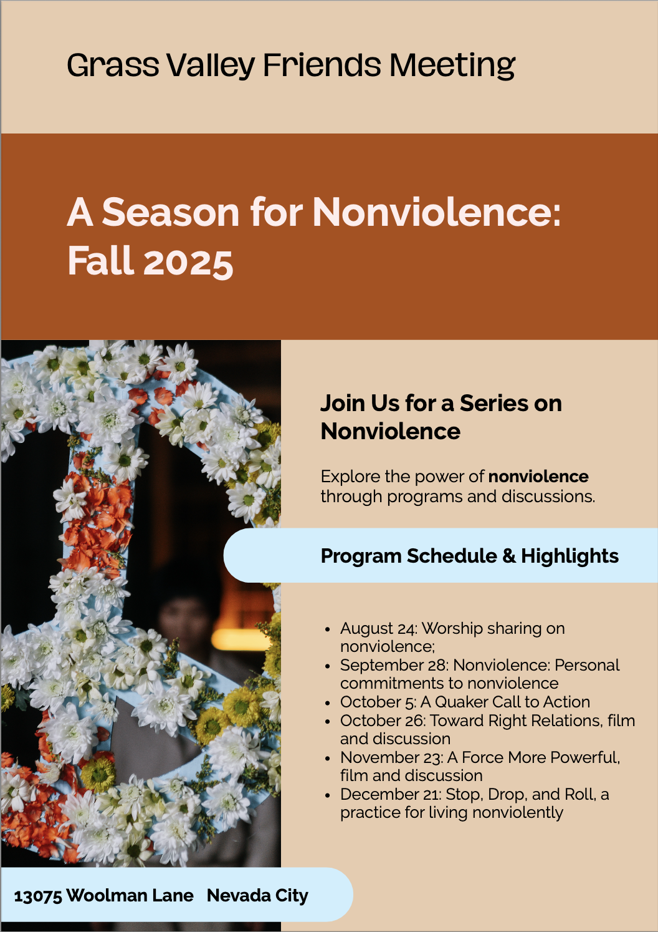

We are also bringing forward for approval a Minute of Service on behalf of Stuart Smith, attached.

25th, Seventh Month, 2025

Blessings of Peace & Joy to all who read this minute:

This letter is an introduction to Stuart E.W. Smith and a Minute of Service from our meeting, Grass Valley Monthly Meeting in Grass Valley, California. (College Park Quarterly, Pacific Yearly).

Stuart is a longstanding member of our Meeting and is in good standing. He is a deeply principled person who acts out of those principles in Spirit-led and heart-centered actions that have contributed to our Meeting and Quakerism for many years. He currently lives in Newcastle, an hour from our Meetinghouse, with his family. He has served on many committees in our Meeting over three decades, including serving as our Clerk. He carries a concern for the education of high school students in the lessons and craft of peacebuilding by using Quaker values. He hopes to listen to the Spirit on this concern and discern a way forward. Following this service call, Stuart is about to complete a PhD in Quaker Studies through the University of Birmingham, England. He himself is a lifelong professional educator in theatre, music, and English.

Stuart has weighty convictions and experience on this subject and has helpful ministry to share on the matter of teaching peacebuilding for you. We believe his presence will bring excitement and hope.

Our Meeting hopes you will open your community to hear Stuart’s ideas and share your questions and aspirations for the young people of this difficult moment.

**Stuart E.W. Smith believes that:**

* There has never been a more proper moment to broaden Quaker education to underserved high school aged youth;
* becoming a knowledgeable and well-trained peacebuilder is more vitally important in our country today than ever;
* such training involves personal development, societal understanding, and a practical understanding of nonviolent activism and its techniques;
* accomplishing this education effectively will require a reimagination of the high school experience; and that
* Quakers’ long history with education as ideally suited for just such a challenge.

We commend Stuart to your tender prayerful care, and ask that you allow him to share his concern. We would appreciate a note of documentation regarding his actions and ministry. We trust you will find him as joyful a presence as we do.

In the Light,

Dorothy Henderson,

Clerk,

Grass Valley Friends Meeting

### Stewardship Committee Report

Report from meeting on August 7, 2025

**Present:** Gordon Starr, convener, Mary Starr, treasurer, Reed Hamilton, Fosten Wilson, Dianne Marshall, newsletter editor.

**Committee clerk.** Mary Starr has agreed to clerk the committee for the 2025 – 2026 term. Gordon Starr will be recorder

**Finance report.** Since the committee did not meet in July, Mary reported for June, donations were $689, with expenses of $820. This included $160 for our annual Zoom fee in addition to typical monthly expenses. For July, donations totaled $699 and expenses were $634. Mary pointed out that the figure of $689 reflects the regular monthly personal and Tithley donations and is about half of the monthly income needed to fund our annual budget of $15.3 k. In addition to other annual donations, Meeting has received a very generous donation that will enable us to fund our year end donations. Without that donation it is doubtful we would have sufficient funds to make those donations – as happened last year. She also clarified that donations to restricted funds do not help fulfill the annual budget.

Mary, Gordon and Fosten agreed to meet on September 1, to work on a new budget. It will be presented at the September Meeting for Business for seasoning.

**Appeal Letter.** In the past, our annual appeal letter has gone out in December as an end of the year request. In discussion, the committee agreed that, given all the demands of time and money at that time of year, December may not be the best time to be asking for donations. Since October is the beginning of our fiscal year, it makes more sense to send it out then. There was some discussion about what should be in the letter. Dianne will again begin work on it.

**Rodents and droppings** Dianne related she was with a guest in the library and there seemed to be mouse poop everywhere they looked. Guest was alarmed. Traps are being set, but no recent results. The issue led to the possibility of moving. See below.

**Expanding GVFM’s presence (and attendance).** We had an extended discussion about how to make ourselves more seen and known. Move to town? Where, costs, when to meet, our library? Hold an evening meeting for worship in town once a month? Some agreement around a shared program with other faith communities a la George Lakey to increase our visibility; dovetailed with Interfaith Nevada County? A public Quaker Call to Action event? We will explore possibilities.

**Next meeting:** September 4, 2025 at 3:00 PM

### Welcome Committee Report

August 4th, 2025 / 7:00PM / Zoom

Attendees: Judy, Kathy, Don and Pete

Opening worship

1. Potluck update
   1. Good turnout for Kathy and Fosten’s potluck
   2. Next potluck will be Friday, Aug 22, 5pm at Pat Philips’ home
2. YubaNet.com Calendar entry
   1. We reviewed:
      1. the possibility of creating a YubaNet calendar entry for our GVFM Worship
      2. current YubaNet Calendar entries for Nevada City
      3. segments of entry format ( a few examples listed below)
      4. *Event – Location – Thumbnail image – Brief description*
      5. Calendar entry is free
      6. Don provided GVFM description to use
      7. We will target completed entry in coming week
3. **YubaNet website overview**
   1. The YubaNet Event Calendar is for events, classes, community meetings, and gatherings of interest to our community. We make free listings available to organizations hosting both ticketed and free events. It is not appropriate for business specials or sales. We are working on creating a business directory that will be more appropriate for these commercial listings.
   2. This is a free service; however, we ask that if you are listing recurring events that include more than six dates or multiple events beyond the next six months, you consider breaking them up by month or week, or upgrading to an enhanced listing. This is not a reflection of the quality of the event but allows us to highlight more options for our readers.
4. Guest book entry by new Worship participants
   1. Any new visitors to Worship make an entry in guest book
   2. Welcome committee follows up with them by email and ask about their experience
   3. They are also added to our email distribution list if they prefer

Next Meeting – Sept. 8th – 7pm

### Nominating Committee Report

No report was given.

### Religious Education Committee Report

**July 9, 2025**

We met via Zoom on July 9th, 2025. Present: Doug Hamm, Judy Hamilton, Reed Hamilton and Dean Olson.

Our first order of business was to decide on a Clerk. Judy Hamilton shall serve as Clerk with Dean Olson helping in working on the third Sunday teacher.

Our teaching and buddy schedule will stay the same.

First Sunday: Don McCormick and Lo Hamm

Second Sunday: Doug Hamm and Reed Hamilton

Third Sunday: Teacher will be someone from Meeting and buddy will be someone from the

Religious Education Committee.

Fourth Sunday: Judy Hamilton and Dean Olson (we alternate teaching and buddy duties)

Third Sunday: We no longer have a dedicated teacher and buddy for this Sunday. We will be asking people from Meeting to help with this to present something they are passionate about or something in their life that has been shaped or enhanced by Quakerism. We hope that this will be meaningful to both the student(s) and the person presenting and facilitate both parties getting to know each other in a deeper manner.

Newsletter article(s): We are going to try to let the newsletter editor know if we are doing a special program. For instance, Doug will be showing a documentary for the next few sessions on non violence and will send a brief announcement to Dianne about that for the newsletter.

Other: Dean reported that a series of books with a curriculum on teaching Native American ways has been donated to Yulica. He and others will review and see about incorporating these lessons into our program.

Our next meeting will be in the Fall.

**College Park Quarterly Meeting report**

No report was given.

**Treasurer’s Report**

08-10-2025

Summary = We are still on track to having a successful financial year, but it is primarily because of one particularly generous contribution made in the first quarter.

This report covers the third quarter of the 2024-2025 fiscal year: April 1, 2025 – June 30, 2025. The contributions you made in those months ($2,036) were welcome, greatly appreciated, but less than our average for one quarter. Our expenses ($2,296) were within our budget and included our annual zoom fee and our Quicken software subscription.

The “Fund Balances” and the “General Fund: Actual vs. Budget” reports are available in the Meeting House – near the library – and by contacting me. The Restricted Funds are unchanged from the previous quarter.

Thank you for all your help. All gifts, both in service to the Meeting and financial are deeply appreciated. Money contributions can be in-person, mailed to my address below, or online by using the “give” button at grassvalleyfriends.org.

Mary Starr, Treasurer

500 Butler Street

Grass Valley, CA 95945

Email = [mstarr2133@aol.com](mailto:mstarr2133@aol.com)

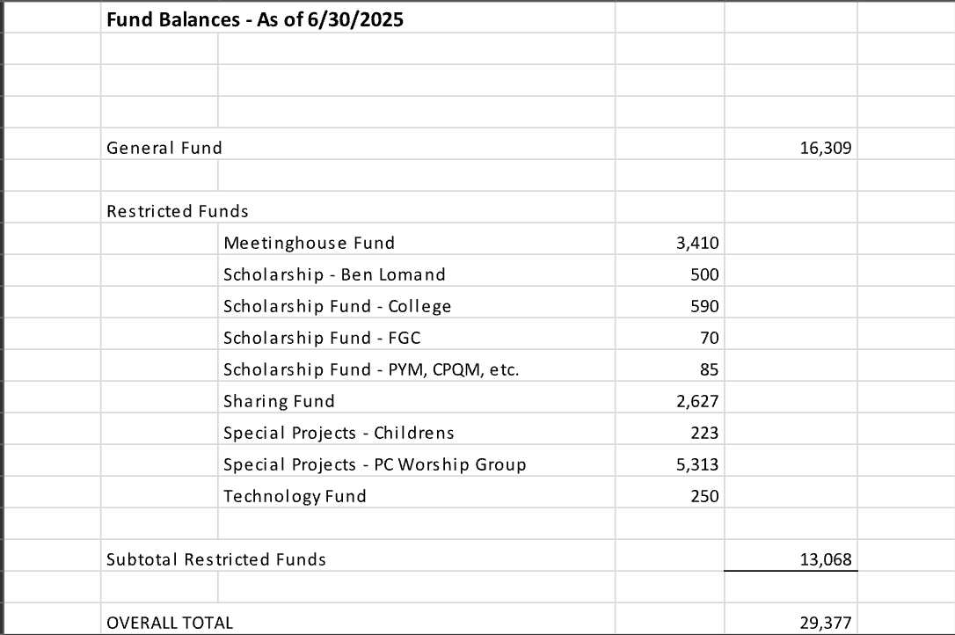

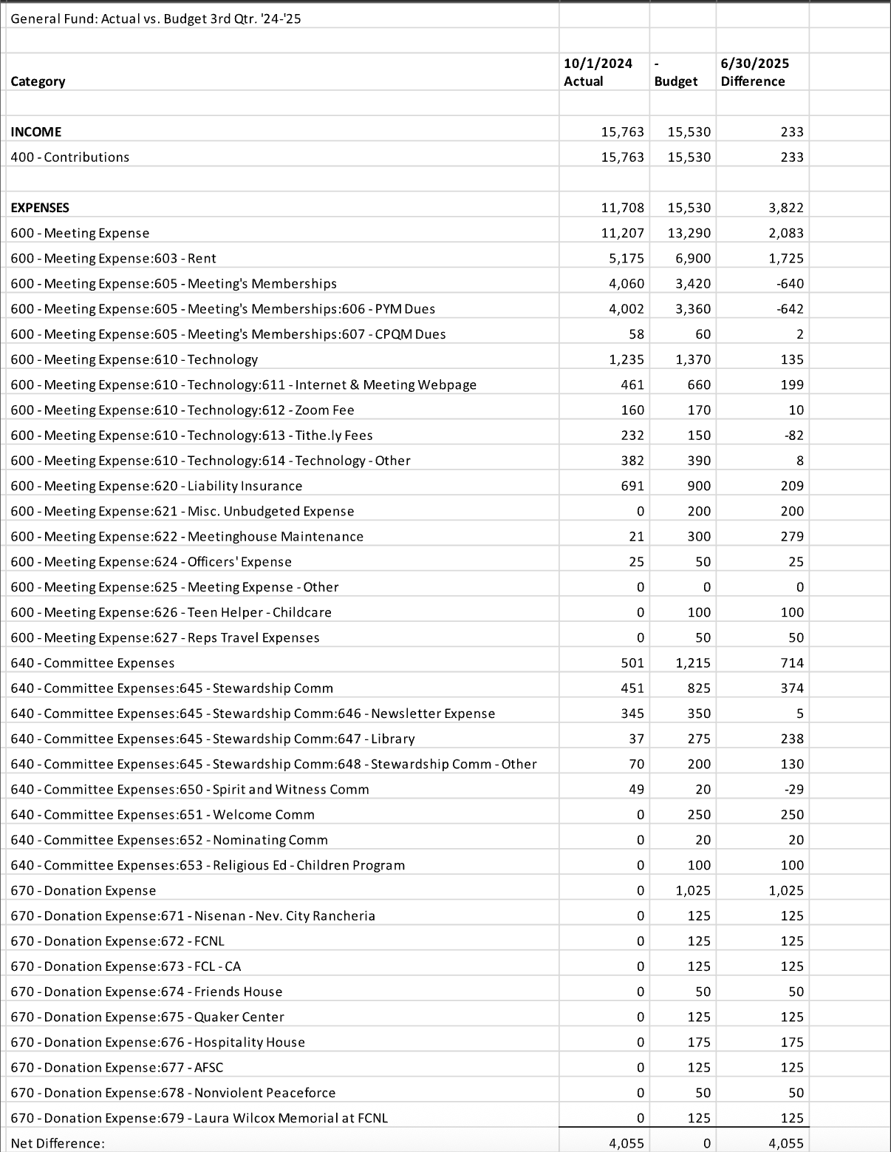

### Pacific Yearly Meeting Report

The Yearly Meeting began with the usual period of worship as attenders on zoom and in- person attenders gathered and settled. Our Clerk’s Table consisted of

* Robin Durante, Clerk, Orange Grove Meeting; with Valerie Nutman, Santa Cruz Meeting, Eldering;
* Sara Rose House-Lightner, Assistant to the Clerk, Berkley Meeting; with Sandy Kewman, Sacramento Meeting, Eldering.
* Joe Magruder, Recording Clerk, Berkeley Meeting.

Roll Call made note of those in attendance from constituent Meetings plus others.

The standard format for daily activities had worship groups, Bible study groups, interest groups as well as activities for Junior Yearly Meeting and youngsters. The 28 Junior Yearly Meeting attendees made a concerted effort to learn more about practices for help with conflict, participating in two sessions of Alternative to Violence Program as practice for peace building. There was also considerable lively participation on the part of our youngest.

A special opportunity at the location of this Annual Session was “Early bird worship” at 6:30am on the roof of the Science Learning Center. A spectacular view of the Los Angeles basin all the way to the ocean was part of the morning worship.

The Saturday Plenary had a panel presentation responding to the theme of this Annual Session, Finding Balance, Heart Reaching Forward. The presenters were:

John Pixley, Claremont Meeting, presented with Shayne Lightner reading his words to aid with understanding, given John’s difficulty communicating because of his cerebral palsy. John shared intimately and humorously of his trials and triumphs given the severity of his physical condition.

Aaron Terry, Honolulu Meeting, shared his experience coming out of military service with a strong desire to work on conflict resolution both internally and externally.

Amy Cooke, Grass Valley Meeting, titled her presentation “Stop, Drop, and Roll,” a fire safety recommendation when caught in flames. She shared her spiritual journey coming through the crisis of losing the home they had built in the Jones fire.

John and Amy’s presentations are on YouTube and can be found on the Pacific Yearly Meeting website.

The Meeting for Memorials is a yearly tradition and takes place Sunday afternoon from 3 to 6pm. The young children are on the floor in the middle with blankets and a quiet hands-on activity. The teens are responsible for introducing the names. A teen stands at the podium, shares a reading, and then announces several names. Messages are then offered on those names before moving on the next names. The Memorial this year had 31 names presented around the top of the wall in the plenary room with each name and monthly meeting on a poster that had been created by Paul Harris’ remarkable calligraphy. Eric Moon, Berkeley Meeting, was one of those who passed away. Eric led our retreat weekend at Gordon and Mary’s a few years back.

Our meeting contributions to this Annual Session in addition to Amy’s keynote were Don McCormick as part of Ministry’s session on Spiritual nurturance on Sunday morning, and Don’s sharing of his Spiritual Journey as one of those daily offerings. In addition, Dorothy Henderson served as co-Elder with Elaine Emily to Amy’s presentation. Dorothy also did morning Bible study (Doug Hamm as Elder) and led a Peace and Social Order Interest group on Nonviolence on Sunday evening. Amy Cooke served as her elder for that session.

The week continued with worship sharing groups, interest groups and plenaries for the business of the yearly meeting. You can read the reports of the committees on the website, as well as the epistle that is written during the meeting and approved at the final plenary on Wednesday.

Respectfully submitted,

Doug Hamm, PYM Representative

### InterFaith Nevada County Report

**June-July, 2025, Report**

The June InterFaith Nevada County met at Peace Lutheran Church, hosted by Pastor Christian Schweter.  The July meeting was held at Unity in the Gold Country, 180 Cambridge Court, Grass Valley, hosted by Rev. Anand Anma.

Upcoming Events shared:

* July 18-20,2025, Alternatives to Violence workshop this weekend at the Unitarian Universalist Church.  Attendance for the whole workshop requested.
* July 27, 2025, 4:00p.m. Mitch Austin will be installed as the minister for the Sierra Center for Spiritual Living. Ceremony location: Unity in the Gold Country church
* August 2, 2025, Dances of Universal Peace, at Unity in the Gold Country, 180 Cambridge Court, Grass Valley
* August 2, 2025, Celebration of Eve Baldwin's life (daughter for GVFM member Peggy Baldwin) Nevada City United Methodist Church 12:00p.m.
* August 23, 2025, 10a.m. -1p.m., Inner Path, *Timeless Truths of the Autobiography of a****Yogi***,
* November 16, 2025, Don Baldwin's 90th birthday to be celebrated at his home with 16 minute showings of his film, "Sequoia Rhapsody". More details to be announced.

Resources shared:

* "Defending Our Democracy: Where we are and what is next", Daniel Hunter, <https://choosedemocracy.us/>
* The Face of the Deep, a Theology of Becoming by Katherine Keller
* Podcast: Buddha at the Gas Pump
* "This England" on BritBox, <https://en.wikipedia.org/wiki/This_England_(TV_series)> a mini-series re: the impact of Covid in England
* Podcast re:; Christian Zionism "'Til Kingdom Come"
* The Wild Edge of Sorrow by Francis Weller
* Parkinson's Support Groups:
  + First Thursday of the month at the Unitarian Universalist Church
  + Third Thursday of the month at the Madelyn Helling Library
* Pastor Christian (Peace Lutheran Church) is anchoring the organization of a “Season of Creation Ecumenical Service.” The World Council of Churches is inviting churches (and interfaith partners) to celebrate the Season of Creation in the month of September, ending October 4 the Day Saint Francis is commemorated by celebrating together in a service of word and prayer and to lift up the care for God’s creation. Reed Hamilton from Friends Meeting has been notified. More details to follow.
* The InterFaith in Shasta County is hosting a week of 40 presentations. (See announcement below.) This approach has captured the imagination of InterFaith Nevada County members who are now looking at how something similar could be offered locally. If you are interested in being a part of the planning process, please contact Dianne Marshall, [dmarshall@pacific.net](mailto:dmarshall@pacific.net).

